Worksheet 7
EEL 4705
Emerging Logic Devices – QCA Logic Transfer

Group #: U IDs:

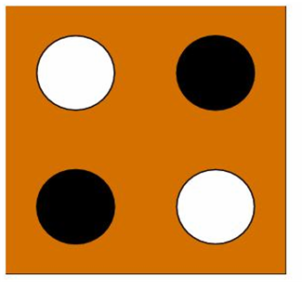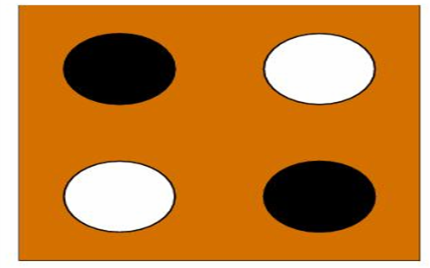 P = 1 P = 0
P = 1
P = 0
Question: Make use of the QCA Cell representation shown above to demonstrate how logic will propagate in the following QCA logic designs.

You need to fill out the dots in each QCA cell to represent whether it’ll be in ‘1’ or ‘0’ state. Start from the Input Cell and fill out all the cells till the Output Cell in the same manner.
(a) A QCA Line
0
Output

(b) A QCA Fanout
Output 3
0
Output 2
Output 1
Output 4
(c) A Crossbar
1
0
Output 2
Output 1

(d) A QCA Inverter

1
Output

(e) A QCA Majority Gate

0
Output 1
1
1
0
Output 2
1
0
1
Output 3
1
1

